For Contract Period 2022-2025

MPAI-4 Protocol

ABI Funded Programs

**THE ABI PARTNERSHIP PROJECT**

**Funded by: Project Managed by:**

***Provides funding to 36 programs across Saskatchewan***



*Last Revised Spring 2022*

ABI Provincial Office

Saskatchewan Ministry of Health

ABI Provincial Office Expectations

The Mayo Portland Adaptability Inventory (MPAI-4) is one of two client outcome measures that ABI Partnership funded programs are expected to collect and submit to the ABI Provincial Office at the Ministry of Health (the other client outcome tool is the Goal Attainment Program Summary).

The MPAI-4 provides an indication of challenges or impairments experienced by clients in their activity and participation. Inventories are filled out after a client’s intake to an ABI program, and either at their 18-month anniversary or discharge from that program (whichever happens first).

This protocol outlines how, by whom, and when these inventories are to be filled out and sent to the ABI Provincial Office. Information about this tool can be found in the manual and in a recorded presentation available at <https://www.abipartnership.sk.ca/staff/pages/Staff-Orientation-MPAI>.

Overview of the MPAI-4

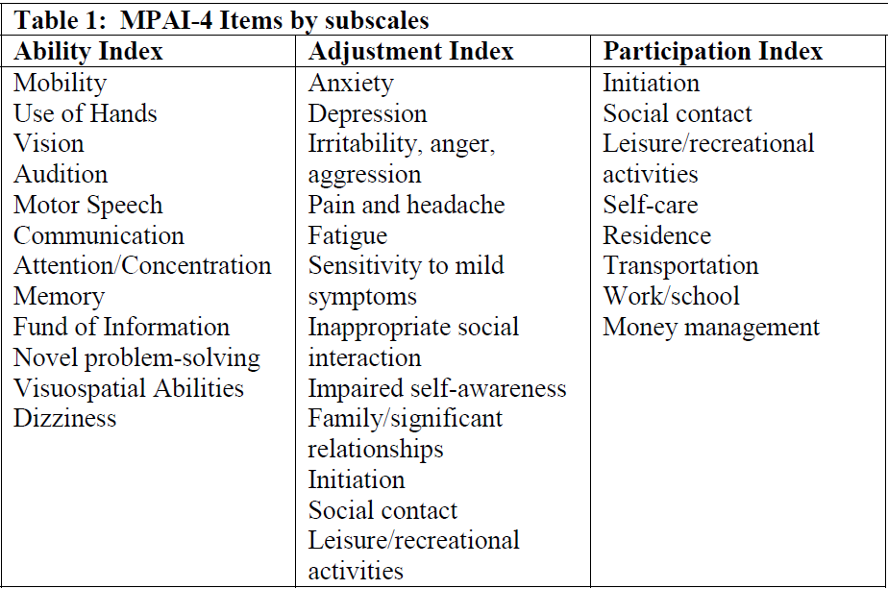The MPAI-4 consists of 35 questions that provide an indication of the challenges experienced by your client after their acquired brain injury (ABI). The questions are divided into three subscales: Ability, Adjustment and Participation.

The rater (either you, your client, or your client’s significant other) indicates for each area whether the client has:

1. No problems; no adaptive devices are used
2. Mild problem that does not interfere with activities; may use assistive device or medication to manage
3. Mild problem; interferes with activities 5-24% of the time; 75% of the time the persons adapts
4. Moderate problem; interferes with activities 25-75% of the time; 24% or less the person adapts
5. Severe problem; interferes with activities 76-100% of the time; rarely can the person adapt

Each MPAI-4 subscale score as well as the total score can be normed against a large sample of ABI clients. This normed rating can tell you how your client is doing, on average, compared to others with ABIs. Each MPAI-4 item represents a common challenge experienced after an ABI, and can provide useful information for goal planning with your client either to indicate areas that might need intervention, or challenges that may interfere with a client’s desired goals.

Protocol for Administration of the MPAI-4

You should review information about the MPAI-4 inventory and each item prior to administering this tool to clients. Information about each item can be found in the manual, Mayo Scoring Tool, and in the recorded training session available at this link: <https://www.abipartnership.sk.ca/staff/pages/Staff-Orientation-MPAI>.

# Time 1: Referrals from ABI Outreach

If your client is referred to your program from an ABI Outreach Team, they will give you a copy of their intake MPAI-4 and will indicate if it is still valid, that is, whether it still reflects the client’s current functioning.

* If this intake assessment is still valid, the ABI Outreach’s intake will serve as YOUR intake assessment. You can use this intake inventory with the client in goal planning.

Notify the ABI Provincial Office that you are using the ABI Outreach Team’s intake using the Mayo Scoring Tool. You will still need to administer a Time 2 inventory.

* If the intake assessment no longer reflects the client’s current functioning, you will administer your program’s own intake MPAI-4 for this client (Go to step 2).

# Time 1: New Clients NOT Referred by an ABI Outreach Team

**Step 1.** **Ask your client and check the Acquired Brain Injury Information System (ABIIS) to see if your client is active with an ABI Outreach Team.**

1. Not active with ABI Outreach - complete an intake assessment with your new client (Go to step 2).
2. Active with ABI Outreach - obtain client consent to request a copy of the ABI Outreach Team’s intake assessment. With client consent, the ABI Outreach Team will give you a copy of their intake MPAI-4 and will indicate if it is still valid (i.e., it reflects the client’s current functioning).

* If this intake assessment is still valid, the ABI Outreach’s intake will serve as YOUR intake assessment. You can use this intake inventory with the client in goal planning. Notify the ABI Provincial Office that you are using the ABI Outreach Team’s intake using the Mayo Scoring Tool. You will still need to administer a Time 2 inventory.
* If the intake assessment no longer reflects the client’s current functioning, you will administer your program’s own intake MPAI-4 for this client (Go to step 2).

**Step 2.** The MPAI-4 should be filled out within 30 days of intake into your program.Explain to your client that theinventory has two functions: 1) to help identify goals that the client could work on, and 2) inventory results are used for evaluation by the ABI Provincial Office. Written consent is only required to send results to the ABI Provincial Office and can be obtained any time before the results are submitted.You can use the information brochure in Appendix A to explain the inventory’s separate use for evaluation.

**Step 3.** If possible,have the client and their significant other fill out an inventory in addition to your ratings. **You should be available to explain each item and answer questions during their completion of the inventory.**

**Subpopulations**

Pediatric Clients

Use the MPAI-4 only for children 5 years and older, and answer as per developmental norms. The parent/guardian’s inventory can be used as a proxy for children under 16 years old.

**Consent.** An individual must be 18 years of age in order to consent to share MPAI-4 information with the ABI Provincial Office. For those younger than 18 years old, have the parent or guardian complete the consent form and complete the significant other version. Although clients under the age 18 cannot consent officially, their consent should still be obtained and co-signed by their parent/guardian.

Severe Injuries

People with very severe cognitive impairment should not complete the MPAI-4. In these cases, their significant other and staff can fill one out as long as the injury is not so severe that the questions cannot be answered accurately.

Older Injuries

Administer the MPAI-4 to ALL new clients regardless of time since their injury. Even if a client is many years post injury, their involvement in your program might result in functional change.

**Step 4.** Assuming the client has consented to sharing information with the ABI Provincial Office (See Consent Form Template in Appendix B), please send the inventory results to the ABI Provincial Office. This can be done in two ways:

1. Mailing the paper inventories with the proper demographics form. If you mail the paper copies, you must score the inventories yourself.

**OR**

1. Enter the inventory ratings into the Mayo Scoring Tool, go to the 5th tab and click “Email Assessment to ABI Provincial Office”. This will open up an email addressed to the ABI Provincial Office with a password protected excel file attached.

**Step 5.** If you entered the MPAI-4 ratings for this client into theMayo Scoring Tool, click “client report” on the 5th tab. This will generate a client report that you can use for goal planning with your client. This report is not sent to the ABI Provincial Office. It highlights challenges experienced by the client that may warrant goal work. Comparisons among raters (staff, client, significant other) are shown on this report, and can identify where perspectives differ. Discussion of these varying perspectives can be useful for program planning. **Print or save the client report.**

# Time 2: Discharge

**Step 1.** Fill out the MPAI-4 again if:

1. **The client is discharged within 18 months** and has been involved long enough to have made progress on some program goals (e.g., likely greater than one month of program involvement). **Note:** **DO NOT** complete a discharge inventory for deceased clients.

**OR**

1. **The client is still active in your program 18 months after intake.** Periodic   
   re-evaluation with MPAI-4 provides an indication of your client’s progress and the appropriateness of their active goals with your program.

**Step 2.** If possible, have the client and their significant other fill out an inventory in addition to your (staff) rated inventory. **You should be available to explain each item and answer questions during their completion of the inventory.**

**Step 3.** As long as at least one rater (either staff, the client themselves, or their significant other) that filled out a Time 2 inventory also had completed a Time 1 inventory, and as long as the client consented to sharing their results with the ABI Provincial Office, please send the inventory results to the ABI Provincial Office. This can be done in two ways:

1. Mailing the paper inventories with the proper demographics form. If you mail the paper copies, you must score the inventories yourself.

**OR**

1. Enter the Time 2 inventory ratings into the Mayo Scoring Tool, go to the 5th tab and click “Email Assessment to ABI Provincial Office”. This will open up an email addressed to the ABI Provincial Office with a password protected excel file attached. You can also generate a client report by clicking “client report” on the 5th tab. This will generate a client report that you can use for goal planning with your client.

## Setting Goals Using MPAI-4 Information

Information gathered with the MPAI-4 can be used to identify functional goals. One of the first steps to working with a client is to identify goals they want to work on or areas they want to improve. Challenges indicated in the MPAI-4 assessment may be useful in this process as it may show potential areas for interventions/goal work, and also may identify barriers to achieving other meaningful goals identified by the client.

The client report generated by the Mayo Scoring Tool identifies where MPAI-4 areas correspond to the goal attainment template, which is the second outcome measure that ABI Partnership funded programs are to submit to the ABI Provincial Office.

Additional Notes:

* If a client withdraws consent, please notify the ABI Provincial Office so that their information can be removed from the MPAI-4 database.
* Please contact the ABI Provincial Office if you require assistance or clarification.

**Last revised April 2016**

**The ABI Outreach intake will serve as YOUR intake assessment. Notify the ABI Provincial Office using Mayo Scoring Tool**

**ABI Outreach Team**

**Still Valid**

MPAI-4 Protocol for ABI Funded Programs

**ABI Outreach will give you a copy of their intake MPAI-4 and will indicate if it is still valid (i.e., reflects the client’s current functioning)**

# Time 1

**Obtain client consent to request a copy of the ABI Outreach Team’s intake assessment**

**New client was referred from:**

**Administer your program’s own intake MPAI-4 for this client**

**No Longer Valid**

**Active with ABI Outreach**

**Is your new client active with an ABI Outreach Team? Ask your client and check the ABIIS**

**Another Source**

**Not Active with ABI Outreach**

Administer the Time 2 MPAI-4 when:

1. You discharge the client from your program, OR
2. 18 months have passed since the client’s intake to your program

Administer the MPAI-4 depending on which of these events happen FIRST. You do not need to submit both an 18-month and discharge measure.

# Time 2

Sharing Results with the ABI Provincial Office

**Appendix A**

**MPAI-4 and ABIIS Information Brochure**

#### **Service Planning & Evaluation**



Insert Your

Program Name Here

Insert Your Contact Information here:

[e.g., Ministry of Health

3475 Albert Street

Regina, SK S4S 6X6

Phone: 306-787-6949

Fax: 306-787-7095]

# SERVICE PLANNING

# &

# EVALUATION

**Facts about the ABIIS & MPAI-4 Questionnaire**

**ABI Partnership Project**



# Acquired Brain Injury Information System:

The Acquired Brain Injury Information System (ABIIS) is used by our program to record client demographic and service utilization information. This information is used by our program for service planning purposes and by the Ministry of Health for service monitoring and evaluation purposes.

**Mayo-Portland Adaptability Inventory:**

You will also be asked to complete the Mayo-Portland Adaptability Inventory-4 (MPAI-4) questionnaire. This information will aid us in your service plan and will also be used by Health to plan for and evaluate services.

You will be asked to complete this questionnaire when you start receiving services from us. You will be asked to complete it again (upon leaving the program, or after a year-and-a-half), and possibly at other times in the future. The staff of our program will also complete a questionnaire and one of your family members or supporters may complete a questionnaire, as well.

**Information Security and Privacy:**

We have procedures in place and computer systems that are designed to protect your information from unauthorized access, use, or disclosures.

The information provided by you and collected about you for the purposes of service delivery and program evaluation will be kept strictly confidential. No information will be released in a way that could identify you personally.

**Questions:**

For further information please contact us.

**INSERT YOUR CONTACT INFO HERE**

BD00028_

# Why do you need information about me?

The services you are receiving from our program are part of the provincial *Acquired Brain Injury (ABI) Partnership Project*, a joint initiative of the Saskatchewan Ministry of Health (Health) and Saskatchewan Government Insurance (SGI).

Receiving services involves providing information about yourself. All individuals who access ABI Partnership services are required to provide basic information about themselves for assessing their needs and planning services for them. This information will also be used by Health to monitor and evaluate how these services are making a difference for people with brain injuries in Saskatchewan.

As part of delivering services we need to share information about you with Health through the Acquired Brain Injury Information System and the Mayo-Portland Adaptability Inventory (MPAI) questionnaire.

#### **Service Planning & Evaluation**

***Appendix B – Consent Form***

***INSERT YOUR PROGRAM NAME***

**Sharing of Information Consent Form**

Name: **\_\_\_\_\_\_\_\_\_\_\_\_\_\_\_\_\_\_\_\_\_\_**D.O.B:**\_\_\_\_\_\_\_\_\_\_\_\_\_\_\_**HSN:**\_\_\_\_\_\_\_\_\_\_\_\_\_\_\_\_\_**

I voluntarily consent to the exchange of verbal and written information, including email concerning my injury and the services I received, for the purpose of my rehabilitation, between the ***INSERT PROGRAM NAME*** and individuals in the following agencies or individual contractors:

|  |  |  |  |  |
| --- | --- | --- | --- | --- |
|  | Organization | Name & Telephone | Additions/Date/Sign | Review date & Initial |
|  | Neurosurgery |  |  |  |
|  | Neuropsychology |  |  |  |
|  | Social Work |  |  |  |
|  | Psychology |  |  |  |
|  | Physiatrist |  |  |  |
|  | Psychiatry |  |  |  |
|  | Family Physician |  |  |  |
|  | Rehabilitation Medicine  In-Patient/Out-Patient |  |  |  |
|  | Case Manager (home) |  |  |  |
|  | Inpatient Health Records |  |  |  |
|  | Mental health services |  |  |  |
|  | Addictions |  |  |  |
|  | Community Day Program |  |  |  |
|  | Special Care Home |  |  |  |
|  | DCRE – Social Services |  |  |  |
|  | WCB |  |  |  |
|  | SGI |  |  |  |
|  | School Division |  |  |  |
|  | Place of Employment |  |  |  |
|  | Early Childhood Intervention |  |  |  |
|  | Child & Youth Services |  |  |  |
|  | Native Coordinator Coun/Band |  |  |  |
|  | ABI residential Program |  |  |  |
|  | ABI Life Enrichment Program |  |  |  |
|  | **Ministry of Health** including MPAI-4 results sent via email in a password protected file |  |  |  |
|  | Sask North Outreach |  |  |  |
|  | Sask Central Outreach |  |  |  |
|  | Sask South Outreach |  |  |  |
|  | ABI Regional Coordinator |  |  |  |
|  | Support Group |  |  |  |
|  | Other: |  |  |  |
|  |  |  |  |  |
|  |  |  |  |  |
|  |  |  |  |  |

(Please initial any/and all additions to this form)

I understand that I can withdraw consent to share information with any individual or agency(s) listed above at any time and this will not affect my access and continuation of services provided by the ***INSERT PROGRAM NAME***.

I understand the information regarding my case will be held in the strictest of confidence and will be disclosed to other parties only with my consent or under the following circumstances:

**(1)** Information pertaining to my case may be shared with other members of the ***INSERT PROGRAM NAME***  when necessary to carry out my service plan;

**(2)** If I have signed a release of information for third party services (such as insurance) the ***INSERT PROGRAM NAME*** may be obliged to release all or any information to the third party; **(3)** If records are subpoenaed the ***INSERT PROGRAM NAME*** is legally required to release information;

**(4)** If I pose a threat to myself or others, confidentiality may be broken in order to prevent harm; &

**(5)** **As part of receiving services through the ABI Partnership Project, information about me & the services received will be entered into the ABI Information System managed by the Ministry of Health.**

I understand that at any point in time I can withdraw from the services provided by the ***INSERT PROGRAM NAME***, thus making this Consent Form invalid.

Client Signature Date

Legal Guardian Signature Date

The meaning and scope of this consent form has been explained to the client and/or the legal guardian. I am satisfied that the intent is understood.

Witness Signature Date